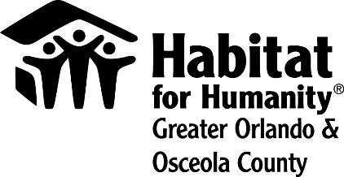
For immediate release
Media contact:
Lauren Delgado
407-567-0010
ldelgado@habitatorlandoosceola.org

B-roll and images: https://bit.ly/2L2DbcW

Habitat for Humanity Greater Orlando & Osceola County reopening homeownership applications for the first time since COVID-19-related closure

Orlando, FL – Habitat for Humanity Greater Orlando & Osceola County will open applications for its homeownership program on May 21, 2020 – the first time since closing the program in March due to the COVID-19 outbreak.

“The uncertainty created by COVID-19 drove us to temporarily close our program. We continue to navigate the new normal of a main office and build sites closed to the public – but a certainty has become even more clear in this time of social distancing. People need access to safe, affordable homes now more than ever,” said Catherine Steck McManus, president and CEO of Habitat Orlando & Osceola.

The application process will open at 10 a.m. on May 21 on HabitatOrlandoOsceola.org/Apply. Accommodations will be made for applicants without access to a computer.

To become a future Habitat homeowner, applicants must have:
- a housing need. The applicant’s current dwelling is overcrowded, transitional, government subsidized, hazardous or unaffordable.
- the ability to pay a mortgage. Future Habitat homeowners need minimum monthly gross income of $2,500 to afford their mortgage and a minimum credit score of 640. More in-depth information on our requirements can be found online at HabitatOrlandoOsceola.org/Criteria.
- a willingness to partner with Habitat Orlando & Osceola by completing homebuyer preparedness classes and sweat equity.

Applicants must also be a resident of Orlando/Orange County or Osceola County.

“We want to make sure our homeowners are prepared for the responsibility of homeownership, so our classes cover everything from creating a budget to maintaining their house,” McManus said.

Habitat Orlando & Osceola is currently building in two planned communities. Juniper Bend in south Apopka will have 10 homes built by Habitat Orlando & Osceola, while Silver Pines Pointe will be made up of 58 homes in the Pine Hills area of Orlando.

About Habitat for Humanity Greater Orlando & Osceola County
Driven by a vision that everyone deserves a decent place to live, Habitat for Humanity Greater Orlando & Osceola County builds affordable housing, repairs homes, and strengthens communities. Families and individuals in need of a hand up partner with Habitat Orlando & Osceola to build or improve a place they call home. Habitat homeowners help build their eventual homes alongside volunteers and pay an affordable mortgage. Working together by donating, volunteering, or becoming an advocate, everyone can help members of their community live in safe, affordable homes.

Habitat Orlando & Osceola is one of Habitat for Humanity International’s affiliates working in nearly 1,400 communities throughout the United States and in more than 70 counties. To learn more, visit HabitatOrlandoOsceola.org, like us on Facebook, and follow us on Twitter, LinkedIn and Instagram.

