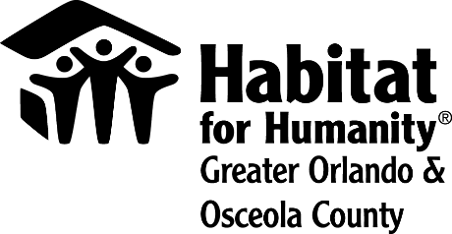
FOR IMMEDIATE RELEASE
Media contact:
Lauren Delgado
407-567-0010
ldelgado@habitatorlandoosceola.org

Habitat for Humanity Greater Orlando & Osceola County to continue
building affordable housing during COVID-19 pandemic
As our community continues to adapt to the instability caused by the COVID-19 pandemic, Habitat for Humanity Greater Orlando & Osceola County and Wells Fargo are working together to provide the security of affordable housing.
The Wells Fargo Foundation will allow Habitat Orlando & Osceola to use a previous $100,000 grant toward any of the nonprofit’s critical needs, including building affordable housing throughout Habitat Orlando & Osceola’s service area in Central Florida.
“By allowing the use of these funds to be broadened, Wells Fargo is helping Habitat Orlando & Osceola to better react to immediate, critical needs during this unstable time,” said Catherine Steck McManus, president and CEO of Habitat Orlando & Osceola.
The uncertainty created by COVID-19 caused Habitat Orlando & Osceola to temporarily close applications for its homeownership program in March. Applications reopened on May 21, until applicant limits were met and exceeded days later.
“People need access to safe, affordable and healthy homes now more than ever,” McManus said. “Partnerships with businesses such as Wells Fargo help us meet this need,” she added.
About Habitat for Humanity Greater Orlando & Osceola County
Driven by a vision that everyone deserves a decent place to live, Habitat for Humanity Greater Orlando & Osceola County builds affordable housing, repairs homes, and strengthens communities. Families and individuals in need of a hand up partner with Habitat Orlando & Osceola to build or improve a place they call home. Habitat homeowners help build their eventual homes alongside volunteers and pay an affordable mortgage. Working together by donating, volunteering, or becoming an advocate, everyone can help members of their community live in safe, affordable homes.

Habitat Orlando & Osceola is one of Habitat for Humanity International’s affiliates working in nearly 1,400 communities throughout the United States and in more than 70 counties. To learn more, visit HabitatOrlandoOsceola.org, like us on Facebook, and follow us on Twitter, LinkedIn and Instagram.

