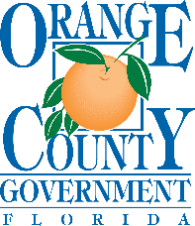
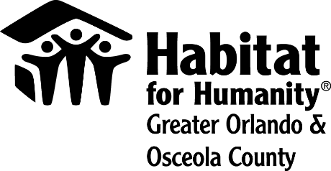
FOR IMMEDIATE RELEASE
Media contact:
Lauren Delgado
407-567-0010
ldelgado@habitatorlandoosceola.org

Habitat for Humanity Greater Orlando & Osceola County and Orange County Government open free roof repair program
Habitat for Humanity Greater Orlando & Osceola County has opened applications to the public for free roof repairs funded by the Orange County Government.
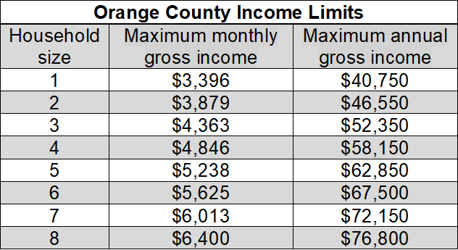
Eligibility requirements include*:
- No mobile or manufactured homes
- Maximum income requirements (please see graph)
- Must own and live in your home
- Taxes & mortgage are current
- Home built 1970-2005
- Located in unincorporated Orange County

*Please Note: The eligibility requirements above are intended provide an overview, rather than an exhaustive list. Award will be subject to approval of final application through Orange County and funding availability.

Applications will be received on a first-come, first-served basis. The program will close when an internal limit has been met.

Interested applicants should visit HabitatOrlandoOsceola.org/Repair-My-Roof/ to learn more about the program and take a prequalification survey, the first step in the application process.

About Habitat for Humanity Greater Orlando & Osceola County
Driven by a vision that everyone deserves a decent place to live, Habitat for Humanity Greater Orlando & Osceola County builds affordable housing, repairs homes, and strengthens communities. Families and individuals in need of a hand up partner with Habitat Orlando & Osceola to build or improve a place they call home. Habitat homeowners help build their eventual homes alongside volunteers and pay an affordable mortgage. Working together by donating, volunteering, or becoming an advocate, everyone can help members of their community live in safe, affordable homes.

Habitat Orlando & Osceola is one of Habitat for Humanity International’s affiliates working in nearly 1,400 communities throughout the United States and in more than 70 countries. To learn more, visit HabitatOrlandoOsceola.org, like us on Facebook, and follow us on Twitter, LinkedIn and Instagram.

