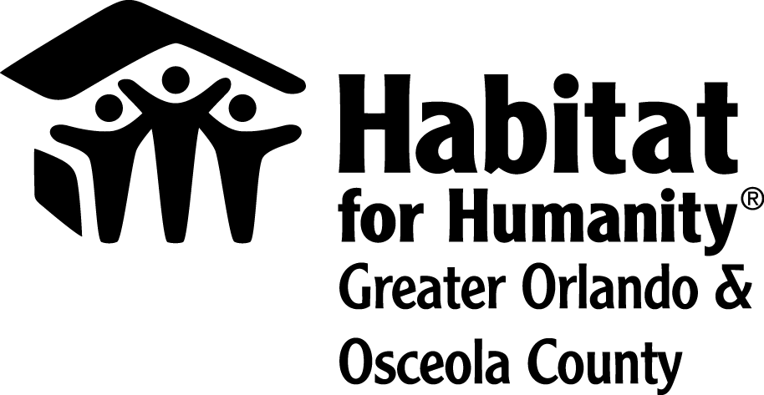
NEWS RELEASE
Contact:
Lauren Delgado
Habitat for Humanity Greater Orlando & Osceola County
407-567-0010
ldelgado@habitatorlandoosceola.org

Habitat for Humanity Greater Orlando & Osceola County announces new Vice President of Resource Development
Orlando, FL (Oct. 22, 2020) – Habitat for Humanity Greater Orlando & Osceola County is pleased to announce the appointment of Vierka Kleinova as Vice President of Resource Development.
Kleinova will be responsible for leading and growing Habitat Orlando and Osceola’s multi-million-dollar fundraising program. She will be a part of the executive leadership team that drives the overall strategy for the organization and represents Habitat Orlando and Osceola on a local, regional and national basis.
“Vierka is more than passionate development professional – she's a thoughtful leader with strong principles,” said Catherine Steck McManus, president and CEO of Habitat Orlando & Osceola. “Coupled with her extensive experience in fundraising and membership service, Vierka will help drive our vision forward: A Central Florida community with access to quality, affordable housing.”
Prior to joining Habitat Orlando & Osceola, Kleinova was the Director of Development for WMFE 90.7 FM (NPR). She worked at the radio station for 17 years in other roles as well, including Director of Membership.
About Habitat for Humanity Greater Orlando & Osceola County
Driven by a vision that everyone deserves a decent place to live, Habitat for Humanity Greater Orlando & Osceola County builds affordable housing, revitalizes neighborhoods and strengthens communities. Families and individuals in need of a hand up partner with Habitat Orlando & Osceola to build or improve a place they call home. Habitat homeowners help build their own homes alongside volunteers and pay an affordable mortgage. Working together by providing financial support, volunteering or becoming an advocate, everyone can help advance access to safe, decent and affordable homes. Help us make the #CostofHome something we all can afford. Habitat Orlando & Osceola is one of Habitat for Humanity International’s affiliates working in nearly 1,400 communities throughout the United States and in more than 70 counties. To learn more, visit habitatorlandoosceola.org, like us on Facebook/habitatorlandoosceola and follow us on Twitter @HabitatOrlOsc.

